

Release Management Process

Revision History

Version Number | Creation/  Revision Date | Prepared /Updated By | Reviewed By | Approved By | Change Description
1.0 | 21.07.2023 | Rajashree M. | Jayanta C. | Jayanta C. | Baseline Version

Table of Contents

1 Objective 4
2 Scope 4
3 Entry Criteria 4
4 Acronyms and Abbreviations 4
5 Inputs 4
6 Process Flow Diagram 5
7 Process Description 6
7.1 Identify the Work Products 6
7.2 Establish Release Environment 6
7.3 Create Build and Review 6
7.4 Prepare Release Document 6
7.4.1 Release to Testing team 6
7.4.2 Release to Client 7
7.5 Perform Release and Communicate to Stakeholders 7
7.6 Post – Release 7
8 Exceptions 8
9 Recommendations 8
10 Permitted Tailoring’s 8
11 Measures 8
12 Validations 8
13 Quality Records 8
14 Exit Criteria 9
15 References 9

- Objective

The objective of Release Management Process is
- To ensure that the product components should be assessed by Release Manager before delivered to the customer
- To assemble the product from the product components.
- To ensure that the integrated product functions properly.
- To ensure that the product/deliverable being delivered possesses the required functionality and quality attributes as expected.

- Scope

This process is applicable to all type of projects that are developed and managed at TECHNO BRAIN.

- Entry Criteria

- Unit testing completed Deliverables that are ready for release to testing team
- System testing completed Deliverables that are ready for External/Internal customer
- Review of Test and Configuration activities to be completed
- Acronyms and Abbreviations

- PMP – Project Management Plan
- DDD- Detailed Design Document
- CM – Configuration Management
- PM – Project Manager
- PL - Project Lead
- PM – Project Manager
- RM- Release Manager
- DO – Development Owner
- DT – Development Team
- TL – Test Lead
- FTP – File Transfer Protocol
- TM – Test Manager
- UAT – User Acceptance Testing
- SQA – Software Quality Analyst
- Inputs
- Baselined Source Code
- Baselined Configuration Management Plan
- Updated Traceability Matrix
- Release Audit Checklist
- Final Delivery Checklist
- Process Flow Diagram
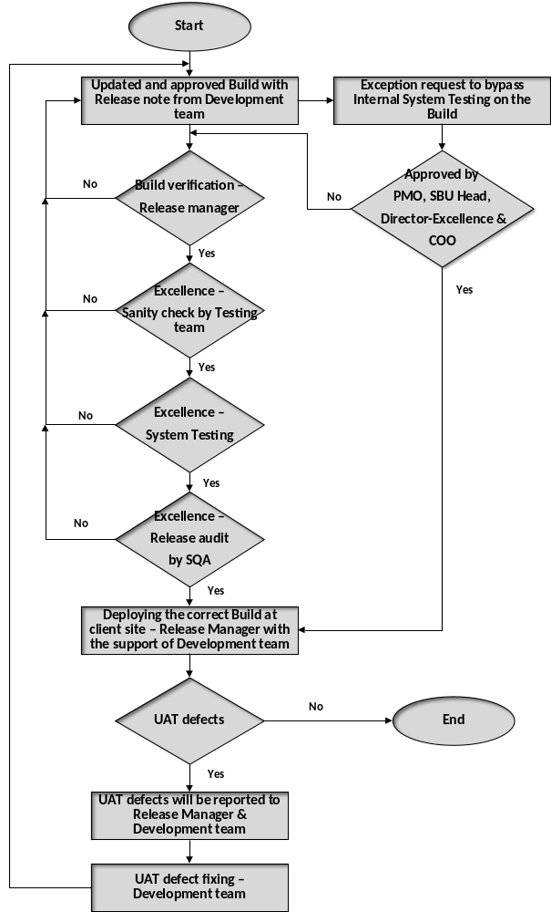
- Process Description
  - Identify the Work Products
  - Identify the product components that has to be delivered as committed in Project Management Plan
  - Identify the work products (SRS, DDD, Test Cases and their test reports etc.,) that has to be delivered as per Plans
  - Identify the type of delivery (Delivery to Testing, Delivery to internal Customer and Delivery to Client)
  - Identify the type of release (Build, Patch etc.,) and mode of release ( VSS, Shared folder etc.,)
  - Product Integration Plan (PIP) and PMP shall be used for projects, as appropriate to schedule releases, specify release environment and database details
  - Product Integration Plan shall be prepared before executing the Build
  - Establish Release Environment
  - Establish the release environment and resources as per the CM/PMP plan
  - Ensure that the latest versions of all components source code are checked in CM tool
  - Ensure that the code is compiled after removing the ‘debug mode’ from the source code.
  - Ensure that the product components and work products are tagged from the configuration management tool with the release version (refer Configuration Management process)
  - This should include DDD, SRS, etc., as per requirements.
  - Create Build and Review
  - Verify the tagged product components and work products as per CM plan
  - Create Build for the identified release version using Build scripts
  - Review the build for its completeness using the Review Checklists
  - The Software Build is baselined after review comments are incorporated
  - Approval is obtained from PO/PL for the release of build to the testing by informing Release Manager
  - Approved build to be installed in separate server, which is only accessed by Release Manager and once it is reviewed and tagged as per naming conventions
  - Release Manager sends to tagged build for testing (Testing team should not accept the build, until reviewed and tagged by Release Manager

  - Prepare Release Document
    - Release to Testing team

  - Once the testing team receives the build from Release Manager, review the build note and verify the build using test readiness checklist
  - Test Manager will verify the build received from Release Manager based on the build readiness checklist and will pass to the testing team
  - Testing team will do a Sanity check on the build and if it fails build will send back to the development team by informing to Release Manager and if it get passed, then it will move to the System and Integration testing
  - The testing team will execute the testing and will track the defects to closure as per Testing Process
  - After completion of SIT, testing team will communicate the System Test Report to PO/PL by informing Release Manager
  - Development Team will fix the defects given by the testing team and will send the updated build to the testing team by following all the above mentioned set of activities
    - Release to Client

  - Once all the build has been tested, Test Manager will inform to Release Manager on successful closure of issues/bugs and is ready for release and approval mail has to be send by Test Manager to Project Manager/Project Lead/SQA Head/Release Manager along with System Test Report
  - Release Manager tags named with “Testing Signed Off” in the separate server
  - SQA will perform the Release Audit as per the (Release Audit checklist, Test Readiness and Final Delivery Checklist) and provide review comments to the PM/PL/RM/TM/SQA Head
  - Development team and testing team will address the respective comments provided by the SQA and will send back the updated review report to the SQA for approval
  - SQA has to ensure all the raised review comments to be closed before release
  - Once approved by SQA, Release Manager tags the build and will deploy it at the client environment with the support of Development team
  - Perform Release and Communicate to Stakeholders
  - Release product to customer. Release manager prepares the operational site for installation of the build. (In some cases, release manager coordinates with customers or end users.)
  - Release Manager will Deploy the build at the client/customer location
  - Release manager will update the respective records

  - Post – Release
  - Once deployment of the build is completed at client/customer location, any identified defects during deployment and UAT. Development team should be track the defects using UAT- Bug tracking sheet.
  - While closing the UAT bugs, if any necessary changes should be done and updated build to be shared to Release Manager for verification and after proper testing is done the build will be released by approval of SQA.
  - Release Manager with the support of Development team deploys updated build at customer/client location.

- Exceptions

  - In case of any urgency or emergency based on business constraints to skip Release Management Process, necessary approvals will have to be taken from COO/SBU-Head/Director-Excellence.
  - Once approval has been taken, Release Manager to be informed.

NOTE: Please refer following below path for Release Management Process, guidelines, checklists and templates

<Q-Step/Custom Process/Build and Delivery>

- Recommendations

Acceptance of Release shall be stored in the Project/Product repository
- Permitted Tailoring’s

Refer Tailoring Guidelines
- Measures

- Effort spent on Release Activities (Planned Vs. Actuals)
- Review effort on Release Activities (Planned Vs. Actuals)
- Rework effort on Release Activities (Planned Vs. Actuals)
- Number of known defects in each release
- Number of Review defects found during the Release Phase
- Validations

- Sanity Test / other required test to verify the build generated
- Configuration Review
- Release Review
- Quality Records

- Software release review records
- Sanity Test reports and CM Review reports
- Build Note
- Final Delivery checklist
- Release Audit Checklist
- Testing Delivery checklist
- Product Integration Plan
- Exit Criteria

- Acceptance from the Customer (Internal / Project Services Head)
- References

CMMI V 3.0
- Process Area: Product Integration
- Organization Roles and Responsibilities
- Validation process

